UrjaGram OS Platform — Intern Assignments
Oct 9, 2026 · @UrjaGram

What you are asked to do
Each intern owns one domain of the UrjaGram platform and delivers a working AI module that turns village data into a concrete action. Together, the ten modules form the platform that helps a village become climate resilient and reach NetZero.
Every assignment follows the same three steps:
- Understand your domain. Learn how your sector works in a village: who the users are, what decisions they make, what data exists, which government schemes apply, and what goes wrong today.
- Identify what AI can do. Find two or three specific decisions in your domain where AI can help. For each, name the user, the decision, the data needed and the action that follows. "Use AI for crops" is not a use case; "Advise a farmer in Kharif which of three crops to sow, given soil, groundwater and forecast rainfall" is.
- Code it for action. Build a working module for the strongest use case. It must take real or realistic data, produce a decision, and trigger an action: an alert, a recommendation, a schedule or an entry in the platform.

Rules common to all
All modules are built to make unified platform, so they must follow the same conventions, connect to each other and report into one NetZero account.
How the platform is organised. Think of a smartphone. Village infrastructure (pumps, panels, sensors, buildings, livestock) is the hardware. The UrjaGram operating layer is the system software. Each intern's module is an app that runs on it, reads shared village data and writes its results back.
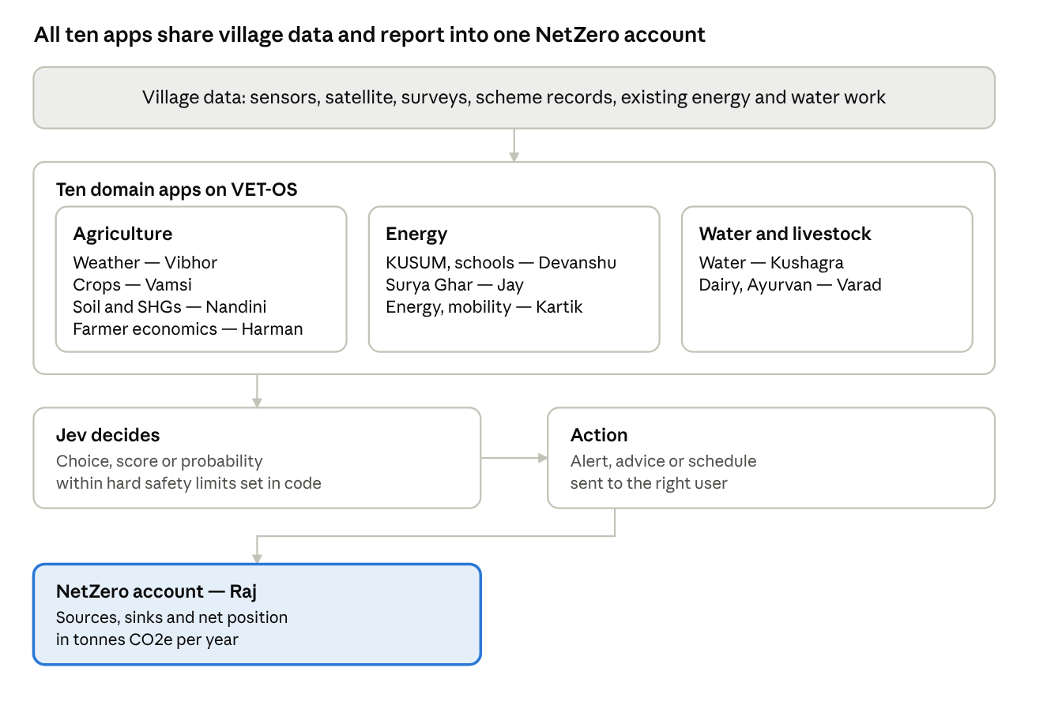
how the ten modules fit · data, apps, decision, action, accounts
Each app reads shared village data, decides with Jev wherever practical, acts, and reports its emissions and sinks to the NetZero account.
Working with a farmer family. Each intern works with at least one farmer family for the whole assignment. The family is the first user of your module.
- Week 1: meet the family and understand their land, crops, livestock, water, energy use, income and the decisions they find hardest.
- Week 2: check your shortlisted use cases with the family. The one you build should solve a problem they recognise.
- Week 4: test the prototype with the family and record what worked, what did not, and what they would change.
- Explain the purpose of the work and take the family's consent. Refer to the family by a code, not by name, in all data and reports.
Coding conventions
- Language: Python.
- One shared GitHub repository, with one folder per domain (for example weather/, crops/, soil/).
- Each folder contains a README (purpose, inputs, outputs, how to run), the code, sample data and at least basic tests.
- Use the common village data format: village identifier, location (latitude, longitude), date and time, and metric units stated in every field name or header.
- Every module that creates or reduces emissions, or stores carbon, sends its figures to the NetZero module (Raj) in tonnes of CO2-equivalent per year.
- Work already built by the Kurukshetra and Jalandhar teams to be taken forward. Build on it; do not rebuild it.
Using Jev for decisions. Jev is a "System One" model released by TypeSafe AI on 15 September 2026. It does not write text; it returns a choice, a score or a probability. The pattern is: a language model writes, Jev decides, code acts.
- Use Jev where the possible answers can be listed in advance, for example "no alert / advisory / warning / emergency" or "sow crop A / B / C".
- Always pair Jev with a hard rule. A safety threshold set in code (for example, a heat or flood limit) can only be raised by Jev, never lowered.
- Log every decision with its inputs, so it can be checked later.
Data and people
- Use public data first and record the source of every dataset.
- Do not collect personal data of farmers, households or students without consent. Sources on Jev: Jev course notes, hands-on review.

Timeline and deliverables
The assignment has four checkpoints, with a progress review every week.
By | Deliverable | What it must contain
End of Week 1 | Domain note (3–4 pages) | How the domain works in a village, key users and decisions, schemes, data sources, current problems, and a profile of the partner farmer family
End of Week 2 | AI use-case shortlist | Two or three use cases, each with user, decision, data, action; one selected for the build, with reasons, checked with the farmer family
End of Week 4 | Working prototype | Code in the shared repository, sample data, README, tests; decision and action working end to end; tested with the farmer family
End of assignment | Demonstration | A live run of the module on village data, and how it links to the other modules and the NetZero account, and the farmer family's feedback

Individual assignments
Each assignment below sets out what to learn, where AI can help, what to build, and which other modules it connects to. Treat the AI ideas as starting points; your Week 2 shortlist may improve on them.

1. Vibhor — Weather intelligence and action triggers
Understand: How weather affects village decisions on sowing, irrigation, spraying, harvest, livestock and health. Learn the data available at three levels: local (village weather stations and sensors), regional (India Meteorological Department forecasts) and satellite (rainfall, temperature, soil moisture, vegetation indices).
Where AI can help:
- Combine local, forecast and satellite data into one village-level forecast.
- Use Jev to decide the alert level and the action, for example "hold irrigation", "delay spraying", "heat advisory for livestock".
- Send the alert to the right user in the local language.
Build: A weather service that other modules can call, plus a Jev-based trigger that turns forecast conditions into a listed set of actions, with hard safety thresholds in code.
Connects to: Crops (Vamsi), Water (Kushagra), Dairy (Varad), Energy (Kartik).

2. Vamsi — Crop choice, water intensity and climate-resilient crops
Understand: The crops grown in each season, how much water each needs per hectare and per rupee earned, and which climate-resilient varieties are available from ICAR and State Agricultural Universities.
Where AI can help:
- Recommend a crop or crop mix for a plot, given soil, groundwater, forecast rainfall and market price.
- Score each crop on water use, income and climate risk.
- Estimate the water saved at village level if farmers shift crops.
Build: A crop-choice adviser that takes plot data and returns a ranked list of crops, with water use and expected income for each.
Connects to: Weather (Vibhor), Soil (Nandini), Farmer economics (Harman), Water (Kushagra).

3. Nandini — Soil types, soil health and Self-Help Groups
Understand: Soil types in the allocated area, the Soil Health Card system, key soil indicators (organic carbon, NPK, pH, salinity), and how women's Self-Help Groups (SHGs) can run soil testing and bio-input production as a livelihood.
Where AI can help:
- Read soil test results and give plain-language fertiliser and organic-input advice.
- Map soil health across the village and flag plots needing attention.
- Plan SHG work: which plots to sample, when, and what inputs to produce.
Build: A soil health module that stores test results, generates advice per plot, and produces a work plan for the SHG.
Connects to: Crops (Vamsi), Water and soil maps (Kushagra), NetZero, since soil organic carbon is a sink (Raj).

4. Harman — Policy, logistics and farmer economics
Understand: The schemes a farmer can use (MSP, crop insurance, credit, FPO support, subsidies), how produce moves from farm to market, and a farmer's real costs, income and risks per acre.
Where AI can help:
- Match a farmer to the schemes they are eligible for.
- Advise when and where to sell, using mandi prices and transport cost.
- Calculate the income effect of any recommendation from the other modules.
Build: A farmer economics engine: input the plot and crop, output costs, income, eligible schemes and best selling option.
Connects to: Every module, since each recommendation needs a cost and income check.

5. Devanshu — PM-KUSUM, community solar and school students
Understand: The three components of PM-KUSUM (solar plants on barren land, standalone solar pumps, solarisation of grid-connected pumps), community-owned solar models, Agri photovoltaics, and how school students can take part.
Where AI can help:
- Size solar for a village's pumps and identify the best KUSUM component, possibility of solar panels on the sides of the agriculture farms.
- Forecast solar generation and schedule pumping to match it.
- Turn student measurements (panel output, pump hours, shading) into usable data.
School students take part in three ways: awareness in their families, data collection on panels and pumps, and practical learning of their science textbooks (electricity, energy sources, measurement) on real equipment.
Build: A solar planning and monitoring module, with a simple data-entry form for students and a classroom activity sheet linked to textbook chapters.
Connects to: Energy (Kartik), Water (Kushagra), Public buildings (Jay), NetZero (Raj).

6. Jay — PM Surya Ghar and public buildings
Understand: PM Surya Ghar: Muft Bijli Yojana for household rooftop solar, including eligibility, subsidy and application process. Also cover rooftop solar for public buildings: Panchayat Bhawan, schools, health centres, Anganwadis and water works.
Where AI can help:
- Estimate rooftop area and solar potential from satellite images or simple surveys.
- Rank households and public buildings by benefit, cost and readiness.
- Track installations and generation, and flag underperforming systems.
Build: On the work done by Naman and Rajveer.
Connects to: Community solar (Devanshu), Energy (Kartik), NetZero (Raj).

7. Varad — Dairy and Ayurvan
Understand: Village dairy (herd, feed, fodder, milk yield, dung and its use for biogas) and Ayurvan (medicinal agroforestry on village land); Starting with the fodder for the cattle
Where AI can help:
- Advise on feed and fodder to raise milk yield and cut methane per litre. Ensure availability of the further round the year.
- Estimate biogas and organic manure from dung, and plan its use.
- Select medicinal species for each plot and estimate income and carbon stored.
Build: A dairy and Ayurvan module covering feed advice, biogas and manure planning, and medicinal species selection.
Connects to: Weather (Vibhor), Farmer economics (Harman), Energy and biogas (Kartik), NetZero (Raj).

8. Kartik — Energy (building on the Kurukshetra team) and transport
Understand: The village energy model already built by the Kurukshetra team: demand by use (homes, pumps, dairy, enterprises) and supply by source. Add transport: tractors, two-wheelers, autos, goods vehicles and their fuel use.
Where AI can help:
- Forecast village energy demand by hour and season.
- Balance demand with solar, biogas, storage and grid supply.
- Plan the shift to electric vehicles and estimate charging needs and fuel saved.
Build: An extension of the existing energy module that adds transport and an hourly demand-supply balance.
Connects to: Solar (Devanshu, Jay), Dairy biogas (Varad), Weather (Vibhor), NetZero (Raj).

9. Kushagra — Water (building on the Jalandhar team) and NBSS&LUP data
Understand: The water reserve and crop advisory work already built by the Jalandhar team. Add land-use and soil data from the ICAR National Bureau of Soil Survey and Land Use Planning (NBSS&LUP), and groundwater data from central and state sources.
Where AI can help:
- Build a village water balance: rainfall, recharge, groundwater draw and crop demand.
- Use soil and land-use maps to identify recharge sites and suitable land for each crop.
- Warn when groundwater use exceeds safe limits.
Build: An extension of the existing water module that adds NBSS&LUP soil and land-use layers and a seasonal water balance.
Connects to: Crops (Vamsi), Soil (Nandini), Weather (Vibhor), Solar pumping (Devanshu).

10. Raj — NetZero platform: sources, sinks and measurement
Understand: How village emissions are counted (electricity, diesel, livestock methane, fertiliser, crop residue burning, waste) and how carbon is stored (trees, agroforestry, soil carbon). Learn standard methods such as IPCC guidelines and Indian emission factors, and how carbon markets require measurement, reporting and verification.
Where AI can help:
- Calculate the village emissions and sinks account from data sent by other modules.
- Estimate tree cover and biomass from satellite images.
- Project the path to NetZero under different interventions.
Build: The NetZero account: a common format every module reports into, a calculation engine, and a dashboard of sources, sinks and net position.
Connects to: Every module; this is the integrating layer.

How work will be assessed
Work is judged on whether it solves a real village decision and runs on the platform, not on the volume of code or pages.
Criterion | What good looks like
Domain understanding | Accurate, specific to the village, sources cited
Farmer family | The module solves a problem the family recognises; their feedback shaped the final version
Use case | A named user, decision, data and action; clear reason for the choice
Working code | Runs on sample village data, has a README and tests, follows the shared conventions
Integration | Uses the common data format, connects to the named modules, reports to the NetZero account
Demonstration | A clear live run, with honest limits and next steps
Points not settled in this brief will be clarified at the weekly review meetings; raise questions and blockers there. Where two modules depend on each other, the interns concerned agree the data they will exchange by the end of Week 2.

